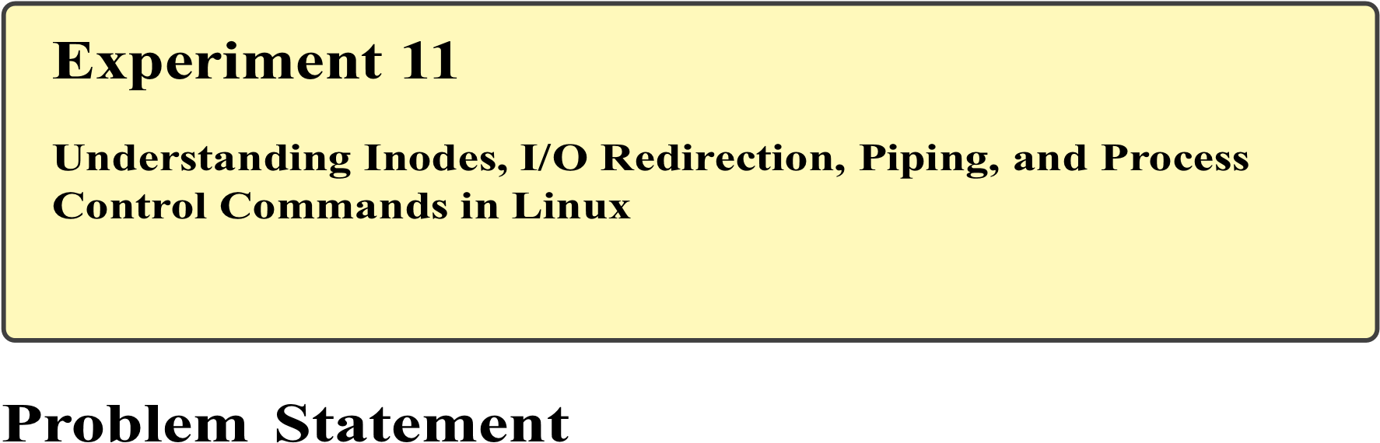
Linux internally manages files using data structures known as inodes, which store metadata about files rather than file names. In addition, Linux provides powerful mechanisms such as input/output redirection, pipes, and process control commands to efficiently manage command execution and system resources. These concepts are fundamental for automation, scripting, system monitoring, and cyber security operations.
The problem is to understand the concept of inodes, practice I/O redirection and piping, and use process control commands to manage running processes in a Linux environment.
Theory

Inodes
An inode is a data structure that stores metadata of a file such as:
- File size
- Ownership
- Permissions
- Timestamps
- Disk location
File names are stored separately in directory entries and point to inodes.

I/O Redirection
Redirection allows changing the standard input, output, or error streams:
- > – Redirect output (overwrite)
- >> – Redirect output (append)
- < – Redirect input
- 2> – Redirect error output

Pipes
Pipes (|) allow the output of one command to be used as input to another command.
Example:
ls | grep txt

Process Control
Linux supports multitasking. Processes can be monitored and controlled using commands such as:
- ps
- top
- kill
- jobs
- bg, fg

Commands Used
ls -i | Display inode number of files
stat | Display file inode details
> , >> | Output redirection
< | Input redirection
` | `
ps | Display running processes
top | Real-time process monitoring
kill | Terminate a process
jobs | List background jobs
bg | Resume job in background
Procedure A. Understanding Inodes
- Create a test file:
touch inode_test.txt
- Display inode number:
ls -i inode_test.txt
- View inode details:
stat inode_test.txt

- Input / Output Redirection
  - Redirect output to a file:
ls > file_list.txt
  - Append output:
date >> file_list.txt
  - Redirect input:
wc -l < file_list.txt

- Using Pipes
  - Combine commands using pipe:
ls -l | grep ".txt"
  - Count number of text files:
ls | grep ".txt" | wc -l
- Process Control Commands
  - Display running processes:
ps
  - Monitor processes in real-time:
top
  - Run a command in background:
sleep 60 &
  - List background jobs:
jobs
  - Bring job to foreground:
fg
  - Terminate a process:
kill <PID>
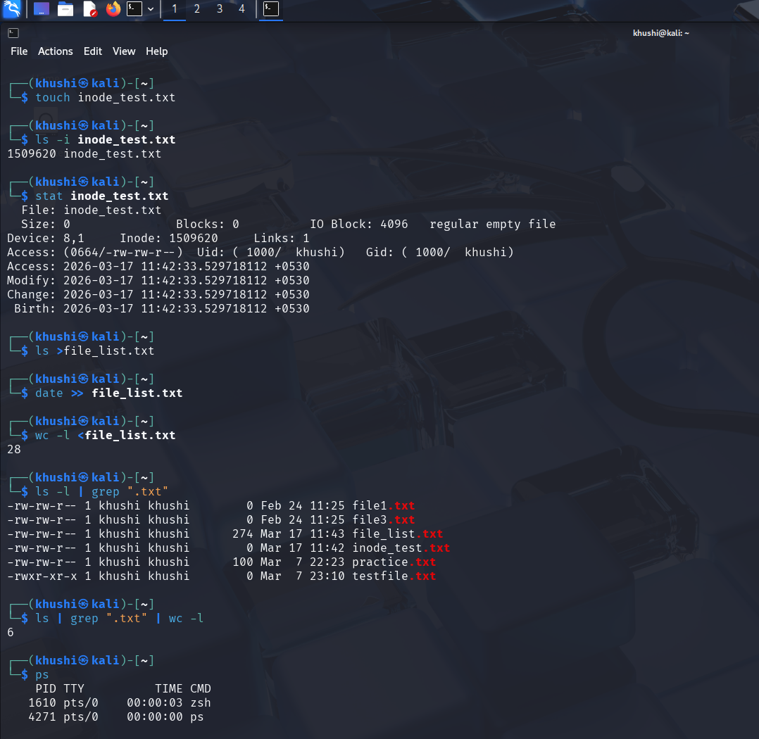

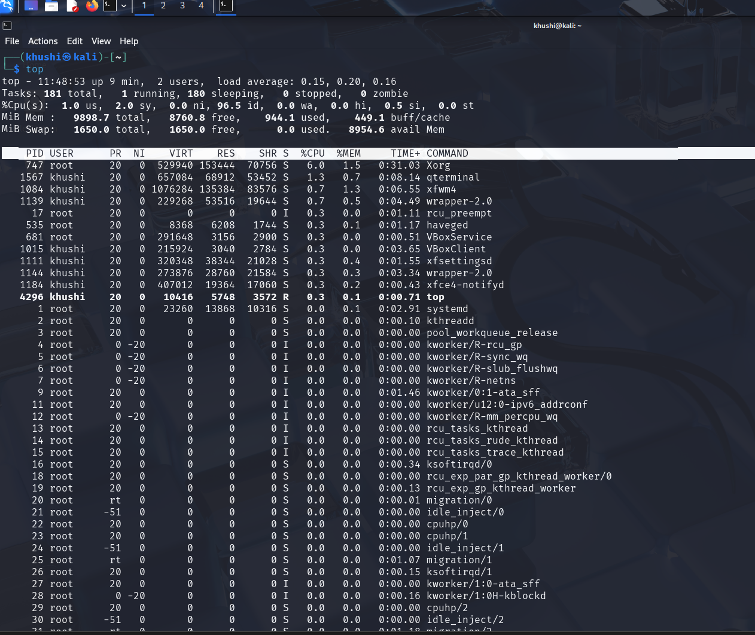

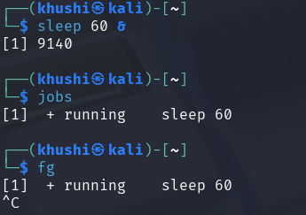

Result
Inode information, input/output redirection, piping, and process control commands were successfully executed. The student gained practical understanding of Linux file system internals and process management.

